Fresh Hope
Evidence to Support Efficacy of the Fresh Hope Support Group Model
May 2020

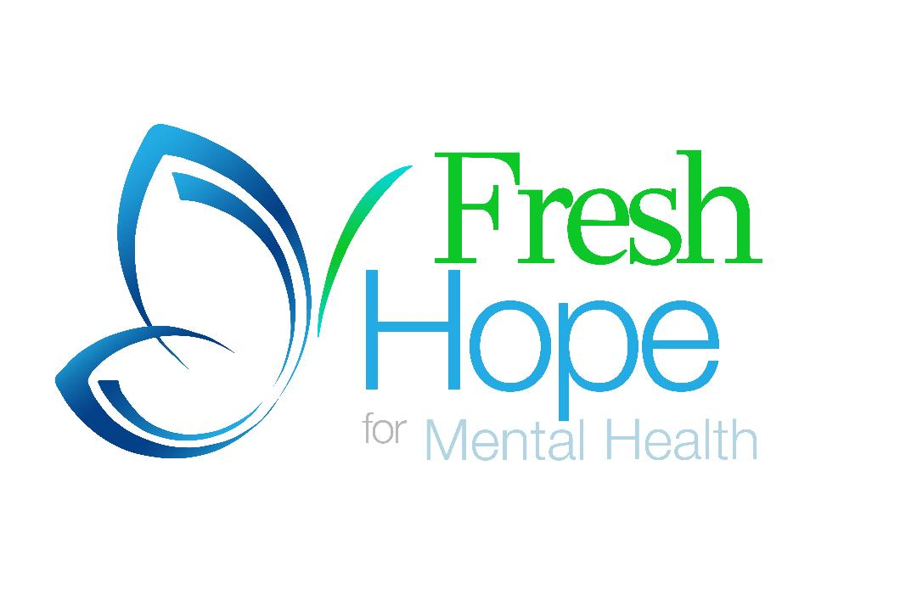

Prepared by:

Disclaimer:
This document was completed using a literature review in May 2020. All information presented is based on research available as of May 2020. Research, therefore, after this date are not included and would need to be considered when further evaluating the program.

Contents

- The Fresh Hope Model
  - About Fresh Hope
  - Fresh Hope Support Groups
  - The Fresh Hope Support Group Difference
  - Recognition
- Evidence to Support Efficacy of Fresh Hope Support Groups
  - Fresh Hope Support Group – Primary Research
  - The Benefits of Religion and Faith on Mental Health
  - Peers
  - Structure
- References
- Appendix
  - Fresh Hope Primary Research

- The Fresh Hope Model

The mission of Fresh Hope is “Empowering individuals to live in spite of a mental health diagnosis along with their loved ones through peer-to-peer Christian mental health support groups that are recovery principle driven.”

About Fresh Hope

Fresh Hope is an international network of Christian support groups for those who have a mental health diagnosis and for their loved ones. At the core of Fresh Hope is the belief that it is possible to live well in spite of having a mental health challenge because of the hope found in Christ; that no matter how one feels, it is possible to still have hope because of Christ.

Fresh Hope provides a variety of different supports to different audiences. Through education and trainings Fresh Hope equips faith leaders to create a mental health ministry within their congregation and builds competencies in supporting those with mental health challenges and their loved ones. Fresh Hope also has online education and a podcast.

Fresh Hope Support Groups
At the core of Fresh Hope, however, are the support groups. A Fresh Hope group is faith-based and peer-to-peer-led with persons with mental health challenges where real hope and real healing can take place. Tenants serve as a backbone to the support group which fosters a positive, new way of thinking, and structure. These groups are also open to the community at all times and are ongoing, meaning they do not have a set amount of sessions.

The Fresh Hope Support Group Difference

Fresh Hope groups are different than other mental health support and/or treatment groups that are widely implemented across the United States today. These differences are what make the program effective in supporting persons with mental health challenges. Key attributes that set the program apart include the full integration of peers, principle driven, faith-based, and the involvement of caregivers. The structure of the program is also different in that it provides long term support, with open access, as opposed to a set number of structured sessions.

Recognition

HE Butts Foundation – Research conducted by the Meadows Mental Health Institute on behalf of the HE Butts Foundation identified Fresh Hope as a Best Practice national model for faith and health initiatives.

The U.S. Department of Health and Human Services, The Center for Faith and Opportunities Initiatives – Recognized as an essential thought partner and leader in faith and mental health support services nationally.

- Evidence to Support Efficacy of Fresh Hope Support Groups

- Fresh Hope Support Group – Primary Research

Fresh Hope conducted an internal study of participants engaged in Fresh Hope support groups. In the study participants self-reported personal value, clinical and behavioral outcomes as a result of their participation in the Fresh Hope Groups. The study revealed that persons engaged in Fresh Hope Groups had a reduction in suicidal ideations, increased hope, and increased insight into their diagnosis. Participants identified that Fresh Hope was crucial to their recovery and that the faith-based component to the program was an essential part of that. (Appendix A)

Highlights of Study:

Personal Value of Fresh Hope
- 96% of the weekly participants in Fresh Hope attribute their participation in Fresh Hope for the reason that they now feel more hopeful than before their participation in Fresh Hope
- 92.3% of those who have attended other mental health support groups before coming to Fresh Hope say that Fresh Hope is more positive and helpful in their recovery than the previous groups, they had participated in.
- 87.5% say that Fresh Hope has been crucial to their recovery. 12.5% say that it has been somewhat important, and 0% say that it has not been important at all.

Clinical Outcomes: Suicide
- 87.5% say that before participating in Fresh Hope they had been suicidal or had suicidal ideations.
Of that 87.5%
  - 52.4% of them say that since attending Fresh Hope they have not been suicidal, nor do they have any more suicidal ideations.
  - 33.3% of them say they have not been suicidal since their participation in Fresh Hope but have had some suicidal ideations.
  - 14.3% report that they have been less suicidal and have fewer suicidal ideations since participating in Fresh Hope.
  - 0% report that they have the same number of ideations or suicide attempts as they had before attending Fresh Hope

Behavioral Outcomes: Skills and Wellness Building
- 94% report they have a better understanding of their diagnosis since attending Fresh Hope.
- 96% report being more compliant to their medical treatment and using wellness skills in their recovery since attending Fresh Hope.

Hope
- 78.3% of the participants say that they are extremely hopeful about being able to live a full and productive life in spite of their mental health diagnosis since coming to Fresh Hope.
- Another 21.7% say that they are “becoming” more hopeful about living a full and rich life.
- 0% say that they do not feel hopeful since attending.

- The Benefits of Religion and Faith on Mental Health

Religion is an important part of recovery because it can offer persons hope, meaning, structure and connection. These strengths build resiliency in persons with a mental health diagnosis which supports recovery. Research supports that persons engaged in religious practices improve mental health disorders, wellbeing and recovery.

Research

- The majority of Fresh Hope Support Groups participants (97%) identified that it is essential Fresh Hope is faith-based (Appendix A).

- Persons with a mental health challenge that engage in religious practices have better mental health. This includes fewer depressive symptoms, increased rates of remission, and a decrease rate of suicide compared to those without religious involvement (Psychiatric Times, 2010).

- Religiousness is a buffer for the impact of life events on depressive symptoms. This research suggests that specific religious practices such as intrinsic religiousness promotes resiliency and can promote long-term recovery (Lorenz, L.; Doherty, A.; Casey, P, 2019).

- Research found a dose-response between religion and/or spirituality and mental health outcomes in U.S. military veterans. Veterans who identified themselves as being religious or spiritual had a decreased risk for Post-Traumatic Stress Disorder (PTSD), Major Depressive Disorder (MDD), and Alcohol Use Disorder. They also had a reduction in suicidal ideation and increased gratitude, purpose in life and post-traumatic growth compared to non-religious or spiritual peers (Sharma V, Marin DB, Koenig HK, et al., 2017).

- Religious methods serve as an important coping strategy to persevere in persons with a severe mental illness (Tepper L., Rogers S., Coleman E., Malony H., 2001).

- In persons with severe mental illness, there is an association between greater time devoted to religious coping and reduced symptoms (Tepper L., Rogers S., Coleman E., Malony H., 2001).

- Persons who became more religious when psychiatric symptoms worsened had fewer hospitalizations (Tepper L., Rogers S., Coleman E., Malony H., 2001).

Entities that Support the Use of Spirituality, Faith or Religion in Mental Health

American Psychiatric Association
American Psychological Association
Mental Health American (MHA):
National Association of Mental Illness (NAMI)

- Peers

Fresh Hope Support Groups are facilitated by peers and the curriculum is developed by peers. Peers have lived experience that offers a unique set of skills that professional medical staff do not possess. Peer support is an evidence-based practice nationally recognized by the Center for Medicare and Medicaid Services. Below is a summary of the value of peers in the recovery and support of persons with mental health challenges.
Efficacy of peers

- Peer support interventions for depression result in greater improvement in depression symptoms than usual care or psychotherapy (Pfeiffer, P. N., Heisler, M., Piette, J. D., Rogers, M. A., & Valenstein, M., 2011).

- Peer support is effective in supporting recovery in persons with a behavioral health diagnoses. Research has found that peer support is associated with a reduction in psychiatric hospitalizations, and a decrease in depression, psychotic symptoms and substance use. Peer support also increases a person’s engagement in self-care and social support, which are both important resiliency factors. (SAMHSA, 2017)

- Peer support positively influences a patient’s clinical and psychosocial outcomes (Fuhr DC, Salisbury TT, De Silva M, et al, 2014).

- According to Mental Health America (2019), peer support services have been shown to:
- Reduce symptoms and hospitalizations,
- Increase social support and participation in the community
- Decrease lengths of hospital stays and costs of services
- Improve well-being, self-esteem, and social functioning
- Encourage more thorough and longer-lasting recoveries

- Persons with a mental health diagnosis who engage in peer supports were found to have an increase in their hopefulness for their own recovery (Cook, J. A., Copeland, M. E., Corey, L., Buffington, E., Jonikas, J. A., Curtis, L. C., ... & Nichols, W. H. 2010).

Endorsement of Peers

The Center for Medical and Medicare (CMS)
National Alliance on Mental Illness (NAMI)
Substance Abuse and Mental Health Service Administration (SAMHSA)
American Psychiatric Association (APA)

- Structure

Fresh Hope groups are unique in that they are peer driven, involve caregivers, offer long-term support and provide a structure. Research supports that these features increase the efficacy of the program for persons with mental illness.

- Mental Health support groups are an effective intervention for persons living with mental illness and their caregivers (Worrall, H., Schweizer, R., Marks, E., Yuan, L., Lloyd, C. & Ramjan, R., 2018).

- Specific attributes that contribute to the success of support groups, include peer leadership, family involvement, and the use of manualized programs (Worrall, H., Schweizer, R., Marks, E., Yuan, L., Lloyd, C. & Ramjan, R.,2018).
Compared to Medical Model

- Peer support groups have similar efficacy to Cognitive Behavioral Therapy groups (Pfeiffer, P. N., Heisler, M., Piette, J. D., Rogers, M. A., & Valenstein, M., 2011).

- Structured group psychoeducation was no more clinically effective than similarly intensive unstructured peer support (Morriss R., Lobban F., Riste L., Davies L., et al., 2016)

- References

APA. Position Statement on Peer Support Services. https://www.psychiatry.org/File%20Library/About-APA/Organization-Documents-Policies/Policies/Position-2018-Peer-Support-Services.pdf. May 2018. Accessed May 20, 2020.

Cook, J. A., Copeland, M. E., Corey, L., Buffington, E., Jonikas, J. A., Curtis, L. C., ... & Nichols, W. H. (2010). Developing the evidence base for peer-led services: Changes among participants following Wellness Recovery Action Planning (WRAP) education in two statewide initiatives. Psychiatric Rehabilitation Journal, 34, 113-120.
Dean, Simon. (2010, January). Religion, Spirituality and Mental Health. Psychiatric Times, 27. https://www.psychiatrictimes.com/schizophrenia/religion-spirituality-and-mental-health Accessed May 24, 2020
Lorenz, L.; Doherty, A.; Casey, P. The Role of Religion in Buffering the Impact of Stressful Life Events on Depressive Symptoms in Patients with Depressive Episodes or Adjustment Disorder. Int. J. Environ. Res. Public Health 2019, 16, 1238. https://www.mdpi.com/1660-4601/16/7/1238/htm. Accessed May 26, 2020
Mental Health America. Peer Services. https://www.mentalhealthamerica.net/peer-services. 2019. Accessed May 20, 2020.

Morriss R., Lobban F., Riste L., Davies L., et al. 2016. Accessed May 26, 2020: https://www.thelancet.com/journals/lanpsy/article/PIIS2215-0366(16)30302-9/fulltext#articleInformation

Fuhr DC, Salisbury TT, De Silva M, et al. Effectiveness of peer-delivered interventions for severe mental illness and depression on clinical and psychosocial outcomes: a systematic review and meta-analysis. Social Psychiatry Psychiatr Epidemiol. 2014;49:1691-1702.

SAMHSA. The Value of Peers. https://www.samhsa.gov/sites/default/files/programs_campaigns/brss_tacs/value-of-peers-2017.pdf. 2017. Accessed May 20, 2020

Sharma V, Marin DB, Koenig HK, et al. (2017) Religion, spirituality, and mental health of U.S. military veterans: Results from the National Health and Resilience in Veterans Study. J Affect Disord. doi:10.1016/j.jad.2017.03.071

Tepper L., Rogers S., Coleman E., Malony H. (2001). The Prevalence of Religious Coping Among Persons with Persistent Mental Illness. Psychiatric Services. https://doi.org/10.1176/appi.ps.52.5.660

Pfeiffer, P. N., Heisler, M., Piette, J. D., Rogers, M. A., & Valenstein, M. (2011). Efficacy of peer support interventions for depression: a meta-analysis. General hospital psychiatry, 33(1), 29–36. https://doi.org/10.1016/j.genhosppsych.2010.10.002
Worrall, H., Schweizer, R., Marks, E., Yuan, L., Lloyd, C. & Ramjan, R. (2018). The effectiveness of support groups: a literature review. Mental Health and Social Inclusion, 22 (2), 85-93.

- Appendix

A. Fresh Hope Primary Research

96% of the weekly participants in Fresh Hope attribute their participation in Fresh Hope for the reason that they now feel more hopeful than before their participation in Fresh Hope

92.3% of those who have attended other mental health support groups before coming to Fresh Hope say that Fresh Hope is more positive and helpful in their recovery than the previous groups they had participated in.

87.5% say that Fresh Hope has been crucial to their recovery. 12.5% say that it has been somewhat important, and 0% say that it has not been important at all.

Hope Measurement

78.3% of the participants say that they are extremely hopeful about being able to live a full and productive life in spite of their mental health diagnosis since coming to Fresh Hope.
Another 21.7% say that they are “becoming” more hopeful about living a full and rich life.
0% say that they do not feel hopeful since attending.
97% say that the fact that Fresh Hope is faith-based is essential to them.

Clinical Outcomes
Self-Reported Results of those who attend our Fresh Hope for Mental Health Group Meetings for Six Weeks:
94% report they have a better understanding of their diagnosis since attending Fresh Hope.
96% report being more compliant to their medical treatment and using wellness skills in their recovery since attending Fresh Hope.

Suicide:
87.5% say that before participating in Fresh Hope they had been suicidal or had suicidal ideations. a.
Of that 87.5%
52.4% of them say that since attending Fresh Hope they have not been suicidal
nor do they have any more suicidal ideations.
33.3% of them say they have not been suicidal since their participation in Fresh
Hope, but have had some suicidal ideations.
14.3% report that they have been less suicidal and have fewer suicidal ideations
since participating in Fresh Hope.
0% report that they have the same amount of ideations or suicide attempts as they
had before attending Fresh Hope
0% report having more ideations or suicide attempts since attending Fresh Hope.

